**Department of Information Technology**

**Government College University Faislabad**

**Software Requirement Engineering**

**Final semester project**

**Group Members:**

**Section:**

**Submitted on:**

**Submitted to:**

Table of Contents

1. Introduction3

1.1 Purpose3

1.2 Document conventions3

1.3 Project scope4

2. Overall Description 5

2.1 Product perspective5

2.2 Use cases and characteristic’s5

2.3 Operating environment6

2.4 Design implementation and constraints6

2.5 dependencies and assumptions6

3. System features7

3.1 Description7

4. Data requirements11

4.1 Use case12

4.2 DFD diagram33

4.3 ERD35

4.4 Class diagram36

4.5 Activity diagram37

5. External interface diagram38

6. Quality attribute41

**1. INTRODUCTION**

**1.1. Purpose**

A departmental store have a speciality that it sell their products in a wide amount without a business setup or we can say that without any network line. Its main purpose is to take care the roles and needs of the all the social levels that are living in the society. The purpose of the departmental store is to give the easiness to the customer and provide them with all the facilities they need in their life. In departmental store the customer has an option of selecting the product select the quantity pay the price and receive the slip.

A departmental store is one of the biggest assets in the retail business. It is necessary to continue at the top level in the landscape retail competition the major need is the departmental store as it helps to continue or run the work you are doing in the good way. Departmental store include the things in them are bags , different brands , women wear , children wears , menswear , beauty products , hand bags for females , technology things , food , toys for children , accessories , gifts and many more things. We can say that their purpose is to give these things to the different levels of people living in the society to fulfill their needs.

It is a multi-standard shopping mall they have the good food, retail, and entertainment brands all available under one place and roof. Their purpose is to provide the facilities to the people they can buy these things via online or by coming and shopping from their store. It's purpose include the important point that in a era of competition everyone trying to sales their products fastly in short time this system will help to sales the product in a short time and compete at best level with other. A departmental store is located at the place where the maximum numbers of people are living that comes for the shopping easily.

Premisis and location are the two key factors of departmental store. We can say that in simple words that the departmental store relate to the meaning that shopping under one roof. They made many different types of usage things and goods for the sales. They have several departments in the departmental store that perform their specific tasks. The term Universal Providers are used for them because they provide the maximum shopping opportunities to the customers that's why they called as the universal providers.

**1.2. Document Conventions**

In document Conventions basically it is a part of document in which the smaller things and lighter for example the heading we made for explaination is written and we bold them that shows that the heading is important that's why we bold them. The font we are using , the italic version we are using for what purpose and underlined a line for what to show that are the things that's the part of the *document conventions*.

We can say that It is the defining of the project. In the document the *line spacing* is about 1.15. All pages except the cover page are numbered and it is mentioned on the right hand corner of page.

* **Bold:** *Main headings*
* **Italic:** Important words in details.
* **Details:** Time new roman 12 black.
* **Heading**s: Time new roman 14 Bold.
* **Ms word:** 2010

The main document conventions points are as following at upper and these include in the document conventions part of Software Requirement Specification.

**1.3. Project Scope**

* The project scope of Departmental store include that the admin have information regarding that how much stock is available for every item. The project scope of Departmental store include that which thing sales a lot so that when they ordered so they can order accordingly to that before the stock sold out.
* The project scope of departmental store include that the record of that how much things are sold out. The project scope for the database of available items the system shall only store information about the available items given in a list. All the data for the departmental store is stored in a single database. It can handle any kind of records such as the Contact number , Names, Address, Date , Texts etc.
* The project scope of departmental store include that the record of that how much things are sold out.
* It is designed or created for the end users that uses the database to perform their job and duties. It is user friendly can cost some expensive but it will be a fast application rather then others or can make an impact. It can save the data of the management , employees that are working in the store or the data of the managerial part like admins and manager of the store under him the system is working. It can be accessible through the internet process. Hiring the equipment and the maintenance work of the store , operational work of the store that's why the stores are required.
* User shall be able to work and continue selling using that system even though internet goes down internet is restored. System shall be able to resynchronize with other terminal & up-to date back-up. User shall be able to open the online application of departmental store and get the product online with just one click only.
* System shall be user-friendly , user shall be able to open new outlet using same data base. It is helpful to keep all history of the customer at one place as it keeps the customer history of purchase which they purchase from departmental store. It is a web based and mobile application.

**2. Overall Description**

# **2.1. Product Perspective**

Our DSMS software is web-based software that has its own database so it can also work offline. It can on multiple systems and all of them will be connected and will be controlled by the admin.

**DSMS Works offline:** DSMS works online but in case when internet is not available then it will use its offline database in-order for you to continue your selling, DSM will automatically resynchronize with other systems and up-to-date back-up

**Inventory Check:** You can check all your stocks and you will be notified if the stock is low. If you purchase anything, Then it will be booked but it will not be removed from the inventory until you pay for it.

**Customer details:** All your customer details will be saved in one place as well as their purchase history so you can any customer details if you want to. And only admin has the right to edit or delete any customer detail.

**Bring your own device (BYOD):** If an employee wants to bring his own device, then he can access the software and it will synchronize with the database, but he will need admin’s permission

**Add-Ons:** You can integrate multiple data in one database it’s synchronize automatically

**Multi-Outlet:** You can open new outlet using same database. You can add more than one user just a click.

**2.2. User Classes & characteristics**

**Favored class**

1. Salesperson
2. Admin
3. Human Resource manager
4. Maintenance team

**Dis-favored class**

1. Out-side person

**Ignored class**

Customer

**2.3. Operating Environments**

**Operating system**

The system will be used in store environment and will be running on more than one system.

**Hardware platform**

The system will have light and efficient UI so it will be able to run-on Low-end systems.

**OS versions**:

The software being developed for the windows. It will support window 7 up to windows 10. But recommended version is windows 10 in order for it to work best.

**Geographical locations of users**:

Currently there is only one outlet of the store located in PIA road johar town Lahore.

**Servers, Database and their hosts:**

The server and database is located in the same building.

**Host website:**

There is currently no website available.

**2.4. Design Implementation and constraints**

**Design constrains:**

These are the restriction that we can not implement in our software due to lack of budget or instructions of customer.

1. The software will not work on anything older than windows 7.
2. The UI should not have any extra features that might confuse or distract the user.
3. The budget should not cross 1 lac.

**2.5. Dependencies & assumptions**

# **Dependencies:**

1. Barcode reader: The system will use barcode reader to scan the barcodes on the products.
2. Credit card machine: The system will use credit card machine to accept payments made from credit card.
3. You have to have a windows version 7 or later in order for the system to run.

# **Assumptions:**

1. The system should need maintenance after every 1.5 or 2 months.
2. The project will need a team of at least 5 persons in order for us to deliver on time.
3. The system will have enough features to run for another 2 or more years, after that it will require an update to match the market. But updating the current software will be fairly easy as there is room for addition of features

Functional requirements

**3. System Features**

**3.1. Description**

Here Departmental store management system features are:

* Log In Admin/Salesperson
* Add New Salesperson
* Delete salesperson
* Buy Product
* Pay Bill
* Sales register
* Sales summary
* Discount for Cash
* Customer Details
* Sales Details
* Payment Details
* Print sales reports
* Delivery Receipt
* Products Inventory
* Print Products Inventory
* Add Product
* Search Products
* Edit Product
* Update Product
* Delete Product
* Forget Username/Password
* Manage sales
* Take order
* Print Bill
* Refunds and sales Transactions

• **Log in Admin/Salesperson:** The DSM software is able to login to both admin and salesperson.

**• Add New Salesperson:** It will add new User for Sales product. In order to add a salesperson, you have to fill some details that are attributes of salesperson which are First Name, Last Name, Phone Number, Email, Additional Info, Password and Verify Password.

**• Delete Salesperson:** admin can delete salesperson.

**• Buy Product:** Customer can buy product in Bin Zafar supper store.

**• Pay Bill:** Customer will pay bill for the product

**• Sales Register:** Salesperson must be registered in order to sell products.

**• Sales Summary:** The DSMS software will have a record for Customer details, sales details, and payment details.

**• Discounts for Cash:** Customers can get some discounts for the products which are set by the admin.

**• Customer Details:** The Customer details will include Customer name, customer address purchase and transection details.

**• Sales Details:** Amount, payment method.

**• Payment details:** Cash and change.

**• Print Sales Reports:** Seller will print sales reports.

**• Delivery Receipts:** Seller will provide the customer delivery receipts.

**• Product Inventory:** There are many products in this inventory so DSM will have a list of every product by name and the quantity of the product.

**• Print Product Inventory:** Through DSM you can print the list of inventory products you have and what is need.

**• Add Product:** Salesperson can add a new product. The product contains those fields which are Item Code, Item Description, Price, Discount and Tax.

**• Search Product:** Through DSM an item can be searched if it is available or not.

**• Edit Product:** The system has option to edit product details where editable fields are Item Code, Item Description, Price, Discount and Tax.

**• Update Product:** The system has option to update product where updatable fields are Item Code, Item Description, Price, Discount and Tax.

**• Delete Product:** The system has option to delete a product where it will delete all the information of the product.

**• Generate Barcode:** The system will create barcodes for products. The barcode will contain Number of Code, Data, Output and Print.

**• Print Barcode Labels:** Print Random Barcode Labels.

**• Barcode Scanner:** Barcode must be scanned for integrity of product. By Barcode Reader.

**• Refunds Products**: It store the product which are returned into stock and update funds, you have to fill some details like Quantity, Item, Description, Unit Value.

**• Refunds and sales Transactions:** After the refund is done it will store this information to the database this information Date, Transaction, Salesperson, Payment Method and Amount.

**• Daily/Weekly/Monthly/Yearly Reports**: The system will make a sales and refund report. The report will have those fields which are Transaction and Stock Report.

**• Print Daily/Weekly/Monthly/Yearly Reports:** Print Daily/Weekly/Monthly/Yearly products sell reports: Through DSM you can also print your Daily/Weekly/Monthly/Yearly sales reports

Functional and Non-Functional requirements for the DSMS (Departmental Store Management System)

**3.1.1. Functional Requirement**

In Software engineering and systems engineering, a functional requirement defines a function of a system or its component. A function is described as a set of inputs, the behavior, and outputs. Functional requirements may be calculations, technical details, data manipulation and processing and other specific functionality that define what a system is supposed to accomplish. Behavioral requirements describing all the cases where the system uses the functional requirements are captured in use cases. Functional requirements are supported by nonfunctional requirements, which impose constraints on the design or implementation

* Login:
* Simple login system including two steps
* Admin login
* Salesperson login
* Manager Control:
* Admin will have access to whole system and can control the system easily
* Admin can add/delete salesperson, further he can also Edit, update, delete, generate barcode etc.
* Salesperson Role:
* Sell Products
* Access to stock reports
* Access to Delivery Receipt
* Payment Process
* Accept Refunds Products
* Payment:
* Cash payment
* Card payment
* Get discounts
* Barcode Integration:
* Barcode will be generated for each product
* Barcode level will be printed on each product
* Barcode scanner will be used to scan barcodes
* Refunds:
* Accept Refunded products
* Cash back
* Reports:
* Repots will be generated of all the process like:
* Sales Report
* Transaction Report
* Refunds Report
* Database:
* A database will be created where all the data of every product and worker will be saved as well as the data of daily weekly and monthly reports

## **3.2.1. Functional Requirement Classification**

|  |  |  |
| --- | --- | --- |
| NO | Requirement Name | Classification |
| 1. | **Login** | **FR1** |
| 2. | Admin Login | FR1.1 |
| 3. | Salesperson Login | FR1.2 |
| 4. | **Manager Control** | **FR2** |
| 5. | Add Salesperson | FR2.1 |
| 6. | Delete Salesperson | FR2.2 |
| 7. | Edit Product | FR2.3 |
| 8. | Update Product | FR2.4 |
| 9. | Delete Product | FR2.5 |
| 10. | Add Product | FR2.6 |
| 11. | Generate Product | FR2.7 |
| 12. | **Salesperson Role** | **FR3** |
| 13. | Sell Products | FR3.1 |
| 14. | Access Stock Reports | FR3.2 |
| 15. | Access Delivery Receipt | FR3.3 |
| 16. | Payment Process | FR3.4 |
| 17. | Accepts Refund Products | FR3.5 |
| 18. | **Payment Process** | **FR4** |
| 19. | Cash Payment | FR4.1 |
| 20. | Card Payment | FR4.2 |
| 30. | Get Discounts | FR4.3 |
| 31. | **Barcode** | **FR5** |
| 32. | Generate Barcode | FR5.1 |
| 33. | Print Barcode | FR5.2 |
| 34. | Scan Barcode | FR5.3 |
| 35. | **Refunds** | **FR6** |
| 36. | Accept Refunded Products | FR6.1 |
| 37. | Cash back | FR6.2 |
| 38. | **Reports Module** | FR7 |
| 39. | Sales Reports | FR7.1 |
| 40. | Transection Reports | FR7.2 |
| 41. | Refunds Reports | FR7.3 |

**3.2.2. Analysis**

The analysis phase defines the requirements of the system, independent of how these requirements will be accomplished. This phase defines the problem that the customer is trying to solve. The deliverable result at the end of this phase is a requirement document. Ideally, this document states in a clear and precise fashion what is to be built. This analysis represents the ``what'' phase. The requirement document tries to capture the requirements from the customer's perspective by defining goals and interactions at a level removed from the implementation details. Priority Check List: Priority check list have three levels.

• Level 1- Must be perform

• Level 2- Mid-level perform

• Level 3- Not required

|  |  |  |  |
| --- | --- | --- | --- |
| NO | Requirement | Priority | Description |
| 1 | Login | 1 | Must be performed |
| 2 | Add Salesperson | 1 | Must be performed |
| 3 | Add Product | 1 | Must be performed |
| 4 | Edit/Update/Delete Products | 1 | Must be performed |
| 5 | Generate Barcode | 1 | Must be performed |
| 6 | Discounts | 2 | Mid-level feature |
| 7 | Products Transection Reports | 1 | Must be performed |
| 8 | Products Sales Report | 1 | Must be performed |
| 9 | Payment Process | 1 | Must be performed |
| 10 | Barcode Scanner | 1 | Must be performed |
| 11 | Database | 1 | Must be performed |

**4. Data Requirements**

**4.1. Use case**

Use case diagram of DSM (Admin Part)

This is the diagram represent whole admin panel access.

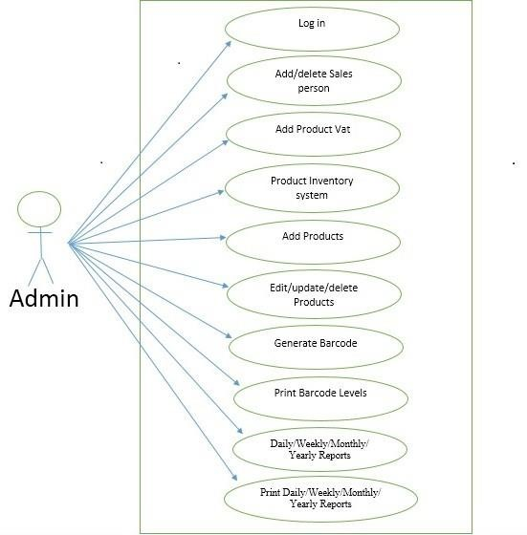

**Use case diagram of DSM (Sales Person Part)**

This diagram Show the features accessible by the sales person

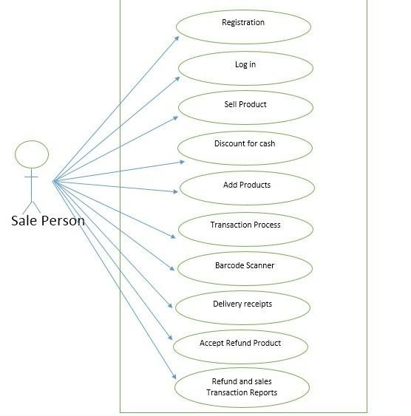

Use case diagram of DSM (Customer Part)

This diagram shows the features that the customer interacts with

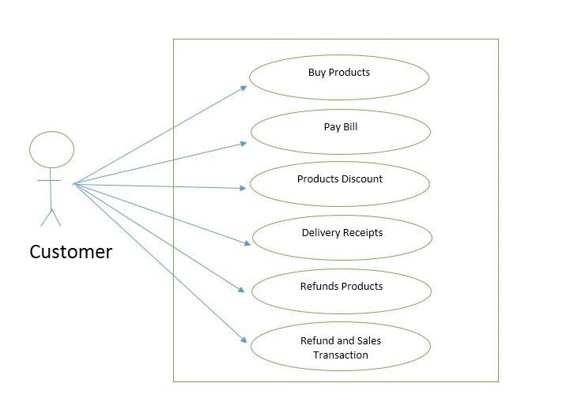

**4.1.1. Fully Dress Use Cases**

|  |  |
| --- | --- |
| **Id and name: #U1** Discount of Cash |  |
| **Created By:** Syeda ifrah |  |
| **Date created:** 21-05-2023 |  |
| **Primary Actors:** Sale person **Secondary Actors:** Customers |  |
| **Description**: Sale person can give discount to customer and he have authority to give any . type of discount to customer. Discount for cash Is the main thing also in the . departmental store. |  |
| **Trigger:** This trigger when customer need the discount and sale person make the changes . and give discount to the customer. |  |
| **Pre-conditions:** 1. Customer can get the discount when buying the product.  2. Sale person set the product discount for making more sales. |  |
| **Post-conditions:** 1. Customer buying the product and get discount successfully.  2. Sale person can see how much discount is offer on all the things. |  |
| **Normal Flow:** 1. Customer can check the product and ask for the discount.  2. Discount will be offer to the customer if it is required.  3. Sale person also give discount automatically when customer buy product. |  |
| **Alternative Flow:** 1. Customer cannot ask for the discount if not mentioned on product.  2. Discount will not be offer to the customer if not mention.  3. Sale person can do nothing if discount is not recorded yet. |  |
| **Priority:** Medium |  |
| **Frequency of use:** It use many time in a day. |  |
| **Other information:** Discount will be increase if you buy number of products more then limit. |  |
| **Assumptions:**  Discount is offer to you. |  |

|  |  |
| --- | --- |
| **Id and name: #U2** Customer Details |  |
| **Created By:** Syeda ifrah |  |
| **Date created:** 22-05-2023 |  |
| **Primary Actors:** Admin **Secondary Actors:** |  |
| **Description:** Customer detail means the personal details of the customers that our store have . Regular customers record of all the details into our system and admin can see any . time when needed. |  |
| **Trigger:** When admin want to see the details |  |
| **Pre-conditions:** 1. First need to record all the details of all the customer.  2. Details of every customer not be recorded only detail of the regular . customer will be recorded. |  |
| **Post-conditions:** 1. Admin just login his system and get access to see and make changes into . the customers details.  2. Admin can take out the print of customers details if needed. |  |
| **Normal Flow:** 1. Simply get the access by login the system and see details.  2. Get the print of the detail if needed. |  |
| **Alternative Flow:** 1. If the data is not being access so first need to be enter the data.  2. Sale person set the product discount for making more sales. |  |
| **Priority:** Medium |  |
| **Frequency of use:** Frequency of the use is not many more just normal because it only access . may be after a week. |  |
| **Other information:** Customer details is also the sensitive information into the store that cannot . be access by any third person it may have personal information of the . customers. |  |
| **Assumptions:** Customers data will be show to the admin |  |

|  |  |
| --- | --- |
| **Id and name: #U3** Sales report |  |
| **Created By: Syeda ifrah** |  |
| **Date created:** 22-05-2023 |  |
| **Primary Actors:** Sale person **Secondary Actors:** |  |
| **Description:** Sale person can imagine and check how many sales he have in a day or week . and even can see the yearly sales from the system and data he have. Actually  . mostly he will use the system for daily sale report check. |  |
| **Trigger:** When sale person login his account then he can check. |  |
| **Pre-conditions:** 1. Cannot check any detail if he will not be able to login his account.  2. Sale person will apply the filter for the date and even if he want to see the . daily, weekly or monthly report of all the previous sales that we have. |  |
| **Post-conditions:** 1. After the login he can check the stat of all the sales that he have and get . proper report of all the sales that they have in a day.  2. Sale person can set the daily limit or target of approach and system give . the percentage how much percent you try to achieve you target or even you . complete it 100% successfully. |  |
| **Normal Flow:** 1. Sale person come and login the system and start working on it and check . all the stat of the sales from here at any time when he want. |  |
| **Alternative Flow:** 1. Sale person cannot login the system and nothing that he can do with . then he report to the admin for solve the issue about it |  |
| **Priority:**  Medium |  |
| **Frequency of use:** Sale person use it several time in a day may be to check again and again . 3 to 4 time in a day or even after the complete day over. |  |
| **Other information:**  Sale person will do the manage all the sales and give all the information . to the admin about the performance then they will take action accordingly |  |
| **Assumptions:** Report will be show to the sale person. |  |

|  |  |
| --- | --- |
| **Id and name: #U4** Payment details |  |
| **Created By:** Syeda ifrah |  |
| **Date created:** 22-05-2023 |  |
| **Primary Actors:** Customer **Secondary Actors:** |  |
| **Description:** Customer can get the payment detail after buying the product and then need to . pay the bill and payment slip will be show and customer need to pay according  . to it. |  |
| **Trigger:** When customer buy the product then he can see the payment details. |  |
| **Pre-conditions:** 1. First customer need to buy the product then after all the products will be . count the total product.  2. After get the count and then system scan all the products.  3. After the scan every product rate will be fix and then get the total bill. |  |
| **Post-conditions:** 1. After the bill issue customer need to be pay.  2. Bill will be paid by the customer after this it will be mark as paid and after . that some of the instruction also be implemented on that means the return . possible date of the product or change the product. |  |
| **Normal Flow:** 1. Customer simply buy the product.  2. Then get the bill after scanning the products from the bar code scanner.  3. After getting bill need to pay. |  |
| **Alternative Flow:** 1. If the product is not buy then system will not be able to generate the . payment details  2. If the customer is in default list then he will not be able to get the . Payment details for the payment of the biil. |  |
| **Priority:** High |  |
| **Frequency of use:** It use several time because every of the customer need the payment details  . and then he can able to pay the bill. |  |
| **Other information:** It is very important for our store because it our system cannot work and  . perform the proper function. |  |
| **Assumptions:** Customer get the payment bill and then able to pay bill. |  |

|  |  |
| --- | --- |
| **Id and name: #U5** Print sales report |  |
| **Created By:** Ayesha marryum |  |
| **Date created:** 22-05-2023 |  |
| **Primary Actors:** Sales report **Secondary Actors:** |  |
| **Description:** Sale report will be create after the customer apply for the report of all the sales . that he have into the day before. |  |
| **Trigger:** When sale person login his portal that access by the admin |  |
| **Pre-conditions** 1. Sale person get the report when he apply for.  2. Sale person can access only after the login his portal. |  |
| **Post-conditions:** 1. After the login sale person can see interface of the portal.  2. Then he can apply for generating the report of the sales. |  |
| **Normal Flow:** 1. Sales person simply login and get the things.  2. That’s simple he will just login and get the things that he want for the sales . report. |  |
| **Alternative Flow:** 1. If sales person fail to login then he need to contact to the admin.  2. After get recovery he can generate the report of the sales that he want. |  |
| **Priority:** High |  |
| **Frequency of use:** Use of the frequency is high because it may be need to generate the report . of the sales every day and may be after the week |  |
| **Other information:** Sales person can generate the report of the sales in a day and it also have . the percentage that we need to target |  |
| **Assumptions:** Print report of the sales to the sale person |  |

|  |  |
| --- | --- |
| **Id and name: #U6** Log In Admin/Salesperson |  |
| **Created By:** Ayesha marryum |  |
| **Date created: 24-05-2023** |  |
| **Primary Actors:** Admin, Salesperson **Secondary Actors:** Bin-Zafar DSMS |  |
| **Description:** In-order to acess the software the user needs to enter their credatials(login) which includes a unique id and a password. The system checks weather the login information is correct or not. Both admin and salesperson have different UI. |  |
| **Trigger:** This use case starts when an actor wishes to log into the DSMS |  |
| **Pre-conditions:** User should be already rigestered in order to login to the software. |  |
| **Post-conditions:** If the use case was successful, the actor is now logged into the system. If not the system state is unchanged. |  |
| **Normal Flow: Log In Admin/Salesperson**  1:The system will ask the user to enter his/her id and password  2:The user will enter their id and password  3: The software matches the entered password and id with the ids in their system and checks its correct or not  4:If the id and password is correct the user will be granted acess to their homepage |  |
| **Alternative Flow: Incorrect Name / Password**  If the user enters a wrong id or password then it will show an error message. The user can then chose weather he wants to return to login screen or cancel login. If the user cancels the login the software will return to the main initial screen |  |
| **Priority:** High |  |
| **Frequency of use:** The employs of the Bin-Zafar store login to the app everyday and there are 15 employs counting only salespersons admin and human resource manager so this will be used atleast 15-20 times perday |  |
| **Other information:** if you forget your password then you can reset it by using the ”Forgot My Password ” button you just have to answer some question to identify yourself |  |
| **Assumptions:** We can assume that a person might login to their account more than once in a day |  |

|  |  |
| --- | --- |
| **Id and name: #UC-7** Generate Barcode |  |
| **Created By:** Fiza |  |
| **Date created:** 22-05-2023 |  |
| **Primary Actors:** Admin **Secondary Actors:** Salesman |  |
| **Description:** There is a distinct symbol(code) printed on every product available in departmental store and by scanning that code from barcode reader, the computer will give all the details related to that product |  |
| **Trigger:** When a new product is added to the inventory. |  |
| **Pre-conditions:** PRE-1: When the product is authenticated  PRE-2: When the admin or requester to generate barcode |  |
| **Post-conditions:** POST-1: New product is added in Bin Zafar store  POST-2: Barcode will be saved in the database of the departmental store Management system |  |
| **Normal Flow: Product is added to the inventory**  System authenticates the product  System generates a barcode for the product  Barcode is saved in the database |  |
| **Alternative Flow: System could not authenticate the product**  System shows reasons why this error is happening  System asks to request for authentication again  Is user skips the authentication process for now then it stores this product in archieve files |  |
| **Priority:** High |  |
| **Frequency of use:** It used a lot because the store keep updating its inventory almost everyday |  |
| **Other information:** Some products may not have a barcode so there will be a unique id for them you have to enter the unique id to get the product details |  |
| **Assumptions:** Each product barcode is assumed to be different |  |

|  |
| --- |
| **Id and name: UC-8** Edit\Delete\Update product |
| **Created By:** Fiza |
| **Date created:** 22-05-2023 |
| **Primary Actors:** Admin  **Secondary Actors:** Sales man,Customer |
| **Description:** If a product is not available in the stock room or inventory then the product can be added, delete and update in the inventory of Bin Zafar Store by entering its name or specific id from requesting it from stock market or by importing its structure from Stock drawing tool. |
| **Trigger:** Admin indicates that he want to add, delete or update the product. |
| **Pre-conditions:** PRE-1: Users identity has been authenticated  PRE-2: User is authorized to request product  PRE-3: Product inventory is online |
| **Post-conditions:** POST-1: Request is stored in the database of Bin Zafar store Management System  POST-2: Request to add, delete or update was sent to the Product Inventory or to the admin |
| **Normal Flow:**  1: Requester specifies the desired product  2: System lists containers of the desired product that are in the Stockroom, if any  3: System gives requester the option to view container history for any container  4: Requester selects a specific container or ask to place a vendor order  5: Requester enters other information to complete the request  6: System stores the request and notifies the admin |
| **Alternative Flow:**  1: Requester searches vendor catalogs for the product  2: System displays a list of vendors for the specific product  3: Requester selects a vendor who have specific product  4: Requester enters the other information to complete the request  5: System stores the request and notifies the admin  5: Requester asks to exit  6: System terminates use case |
| **Priority:** High |
| **Frequency of use:** Approximately 20mtimes per week by each customer, 100 times per week by Stockroom staff |
| **Other information:** The system should add, delete or update product more than once |
| **Assumptions:** Imported product structures are assumed to be valid |

|  |
| --- |
| **Id and name: #UC-9** Print Barcode Labels |
| **Created By:** Zainab zahid |
| **Date created:** 22-05-2023 |
| **Primary Actors:** Admin **Secondary Actors:** Sales man\Customer |
| **Description:** Once the Barcode is generated, our system shows the printed barcode from which we can make difference between different products and the barcode will give us the details of that specific product which is scanned |
| **Trigger:** When the admin gives permission to print the Barcode |
| **Pre-conditions:** PRE-1: Product will be authenticated  PRE-2: Barcode is printed on each product separately  PRE-3: The products will sent to the inventory at their places |
| **Post-conditions:** POST-1: barcode reader can scan the product  POST-2: Barcode reader gives us the details about that specific product |
| **Normal Flow: Each product is authenticated firstly**  1. Barcode for each product will be printed on the product  2. The details about barcode of the product will be saved to the inventory  3. The products will be sent to their places in Inventory |
| **Alternative Flow: Product will be given a unique id for specific product**  1. The unique id will be saved in database for every product  2. While purchasing the product, unique id will be mentioned in the system by the sales person  3. The system will give details about the product with unique id |
| **Priority:** High |
| **Frequency of use:** Its frequency of use will be high because it cn be used on the daily basis |
| **Other information:** When the barcode is printed, it will also save all the details about that product in tha database management system |
| **Assumptions:** Local products are assumed to not have a barcode |

|  |  |
| --- | --- |
| **Id and name: #U10** Delivery receipt |  |
| **Created By:** Mahnoor |  |
| **Date created:** 22/5/2023 |  |
| **Primary Actors:** Customer  **Secondary Actors:**  Cashier |  |
| **Description:** The delivery receipt use case is the recognition of payment for the successful delivery of a product for a specific destination. It allows the user for the confirmation that their product is delivered |  |
| **Trigger:** This use case is triggered when customer booked the order |  |
| **Pre-conditions:**  Pre- 1. The written order placed by the Buyer for the delivery of good.  Pre- 2. Payment from the customer side must be verified. |  |
| **Post-conditions:**  Post- 1. The slip was sent to the customer for order delivery confirmation  Post- 2. The SMS send to the customer via E-mail or text . |  |
| **Normal Flow:**  1. The system check the order is still or cancelled  2. Check the location of the customer where receipt should be delivered  3. System mention date/time/price e.c.t on the receipt |  |
| **Alternative Flow:**  1. Delivery receipt not held so message send to the customer.  2. Checking the detail of the customer whether defaulter or not |  |
| **Priority:** Medium |  |
| **Frequency of use:**  Approximately 100 to 200 time in a day |  |
| **Exception:**  E1. Person doesn’t exist in the database  E2. Receipt send to another person |  |
| **Assumptions:** Receipt send to the customer on desired location |  |

|  |  |
| --- | --- |
| **Id and name: #U11** Product Inventory |  |
| **Created By:** Ayesha marryum |  |
| **Date created:** 22/5/2023 |  |
| **Primary Actors:** Owner  **Secondary Actors:** Admin |  |
| **Description:** Inventory is the quantity of a particular product that is available for sale  Owner must have an access to the inventory of the software. Futher, the owner checks the detailed view of the inventory. |  |
| **Trigger:** When owner want to check the inventory of the products |  |
| **Pre-conditions:**  PRE- 1 Check stock of products left in inventory  PRE- 2 Identifying the person accessing is valid or not |  |
| **Post-conditions:**  Post- 1 The detail of the inventory shown to the manager or owner  Post- 2 The message sends to the owner accessing the inventory. |  |
| **Normal Flow:**  **1.** Owner request to check inventory  **2.** Confirmation of the owner valid or not  **3.** Authorization given to owner  **4.** The owner will go through the inventory  **5.** In inventory the owner will alert about the product in the stock |  |
| **Alternative Flow:**  **1.** If inventory is not open the owner must be able to restart the software.  **2.** The owner access the original database |  |
| **Priority:** Medium |  |
| **Frequency of use:** Approximately 1 or 2 time in week. |  |
| **Exception: 1.** Product inventory in not available in the stock  **2.** Invalid user want to access the inventory |  |
| **Assumptions:** The inventory must be visible to the owner |  |

|  |  |
| --- | --- |
| **Id and name: #U12** Add Stock |  |
| **Created By:** Mahnoor |  |
| **Date created:** 22/5/2023 |  |
| **Primary Actors:** Manager  **Secondary Actors:** Admin |  |
| **Description:** This use case allows the Manager to add new stock of the Product while the stock may be of different category. |  |
| **Trigger:** When manager wants to add some stock |  |
| **Pre-conditions:**  PRE-1 Users identity has been authenticated  PRE-2 User is authorized to add stock in the inventory |  |
| **Post-conditions:**  Post-1 The stock is available by the database to the manager.  Post-2 The inventory changes must be updated.  Post-3 The system shows to add new stock/check stock in the pharmacy |  |
| **Normal Flow:** Request to add the stock in the inventory  1. Requester log-in to the system  2. waiting for authentication  3. Access the inventory results  4. Able to add the inventory |  |
| **Exception:**  **1.** The Manager adds into the wrong product of the same stock  **2.** Invalid user want to access the inventory |  |
| **Priority:** Medium |  |
| **Frequency of use:** Approximately 4 times in the month |  |
| **Assumptions:** Stock added by the manager |  |

|  |  |
| --- | --- |
| **Id and name: #U13** Search Product |  |
| **Created By:** Ayesha marryum |  |
| **Date created:** 22/5/2023 |  |
| **Primary Actors:** Cashier  **Secondary Actors:** Admin |  |
| **Description**: The cashier searches the product for the customer with different varieties of the same product along with this makes the search product to the highest line in different catalog . |  |
| **Trigger:** When cashier wants to give the product to the user |  |
| **Pre-conditions:**  **1.** First the product is available to the stock.  2. The searched product must be accessed to the cashier.  3. The customer request the cashier to buy the product. |  |
| **Post-conditions:**  1.The searched item must be on the interface of the cashier system.  2. The Product shown to the customer in all of the varieties of the same product. |  |
| **Normal Flow:**  1. Cashier request to see the product.  2. checking product in the stock  3. Show the searched product to the cashier.  3. The product to be searched more time comes first . |  |
| **Priority:** High |  |
| **Frequency of use:** Approximately500 to 1000 times in a day |  |
| **Assumptions:** Product shows to the customer with different catalog |  |

|  |  |
| --- | --- |
| **Id and name: #U15** Inventory Reports |  |
| **Created By:** Zainab Zahid |  |
| **Date created:** 26/5/2023 |  |
| **Primary Actors:** Admin **Secondary Actors:** cashier |  |
| **Description:**  The admin checks the daily ins and outs of the inventory by entering the name or Id of a specific product or the whole inventory. Along with this the update, delete or change the reports by checking this. |  |
| **Trigger:** When Admin wants to check the details of the inventory |  |
| **Pre-conditions:**  PRE-1 Users identity has been authenticated  PRE-2 User is authorized to request inventory reports  PRE-3 Inventory database must be online |  |
| **Post-conditions:**  Post-1 The view of inventory is available by the database to the cashier.  Post-2 The inventory changes must be updated. |  |
| **Normal Flow:** Request to see the inventory reports  1. Requester log-in to the system  2. waiting for authentication  3. Access the inventory results |  |
| **Alternative Flow:**  1. Authentication doesn’t match  2. Invalid Login message show  3. Message of Invalid authentication goes to the manager |  |
| **Priority:** Medium |  |
| **Frequency of use:** Approximately 3 times in a week |  |
| **Other information:** The system must be able to change, update, inventory by the user |  |
| **Assumptions:** Inventory shown to the Admin |  |

|  |  |  |  |  |  |
| --- | --- | --- | --- | --- | --- |
| **U-C#16: Forget user name/ Password** | | | | | |
| **Created By: Fiza** | | | | | |
| **Date created:** 22/5/2023 | | | | | |
| **Actors:** Owner, manager, shopkeeper staff | | | | | |
| **Feature** all those users that are password with the system will be able to forget username password | | | | | |
| **Use case Id:** | | | **3** | | |
| **Pre-condition** | | | Forget username password option must be available | | |
| **Scenarios** in this user will be able to forget password | | | | | |
| **Step#** | **Action** | | | | **Software Reaction** |
| **1.1** | The user will have an option to forget the password | | | | The system shows forget option |
| **2.2** | The user will have an access to forget usernames. | | | |  |
| **N** |  | | | |  |
| **Alternate scenario:** user can’t remember his personal information | | | | | |
| **1a:** in case of error the owner must be able to restart the software  **2a:** In case the user can’t remember his information, he will be asked to enter the last 3 words of his password | | | | | |
| **Post-Conditions** | | | | | |
| **Step#** | | **Description** | | | |
| **1** | | The user can set his user name password again | | | |
| **Use case Cross referenced** | | | | Login | |

|  |  |  |  |  |
| --- | --- | --- | --- | --- |
| **U-C#17: Manage sales** | | | | |
| **Created By:** Fiza | | | | |
| **Date created:** 22/5/2023 | | | | |
| **Actors:** Owner | | | | |
| **Feature** owner must have an access to the sales of the software | | | | |
| **Use case Id:** | | | **5** | |
| **Pre-condition** | | | Owner have an access to get the per-day, week, month sales report | |
| **Scenarios** | | | | |
| **Step#** | **Action** | | | **Software Reaction** |
| **1.1** | The owner will go through the sales option | | | The system shows sales of the Departmental store. |
| **Alternate scenario:** | | | | |
| **1a:** in this owner get the reports of the sales of the Departmental store from the system | | | | |
| **Post-Conditions** | | | | |
| **Step#** | | **Description** | | |
| **1** | | The sales Product must be visible in the system | | |
| **2** | | The owner gets reports of the sales in excel in hard and soft form. | | |

|  |  |  |  |  |
| --- | --- | --- | --- | --- |
| **U-C#18: Take order** | | | | |
| **Created By:** Syeda ifrah | | | | |
| **Date created:** 24/5/2023 | | | | |
| **Actors: shopkeeper/staff** | | | | |
| **Feature** staff check the desired product and enter that Product into the system | | | | |
| **Use case Id:** | | | **6** | |
| **Pre-condition** | | | Staff enter that on the system to the availability | |
| **Scenarios** | | | | |
| **Step#** | **Action** | | | **Software Reaction** |
| **1.1** | Customers come to the Departmental store and ask for a particular Product staff of the store to enter that Product into the system. | | | The system shows the availability of that Product in the system |
| **Alternate scenario:** customer have to wait some days | | | | |
| **1a:**  staff takes the order of the Product from the customer | | | | |
| **Post-Conditions** | | | | |
| **Step#** | | **Description** | | |
| **1** | | After checking in to the system if Product avails the staff takes the order | | |

|  |  |  |  |  |
| --- | --- | --- | --- | --- |
| **U-C#19: Print Bill** | | | | |
| **Created By:** Fiza | | | | |
| **Date created:** 22/5/2023 | | | | |
| **Actors: Shopkeeper/staff** | | | | |
| **Feature** after checking the product staff print bill from the system | | | | |
| **Use case Id:** | | | **7** | |
| **Pre-condition** | | | Shopkeeper prints bill of the product to the shopkeeper | |
| **Scenarios** | | | | |
| **Step#** | **Action** | | | **Software Reaction** |
| **1.1** | Shopkeeper print bill after giving product to the customer | | | The system prints bills |
| **Alternate scenario:** | | | | |
| **1a:**  shopkeeper prints bill to the customer after getting the customer’s name | | | | |
| **Post-Conditions** | | | | |
| **Step#** | | **Description** | | |
|  | | Staff print bills | | |

**4.2. DFD Diagram**

**4.2.1. DFD – 0**

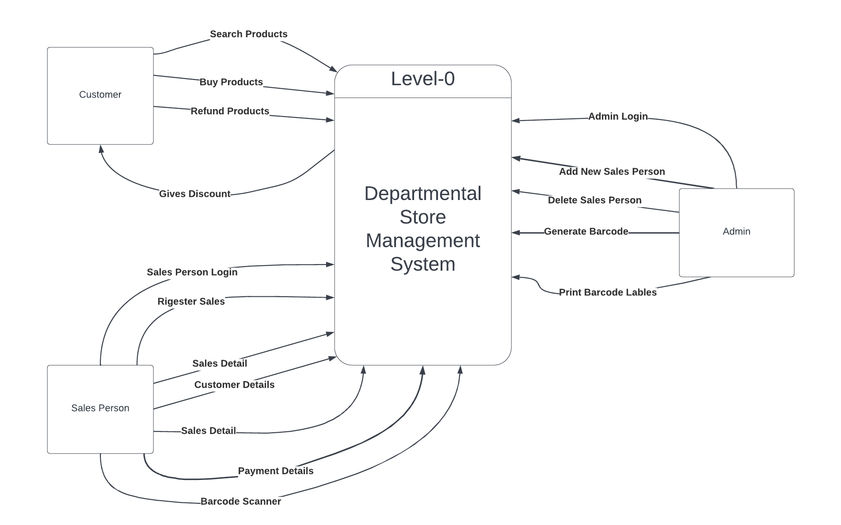

**4.2.2. DFD - 1**

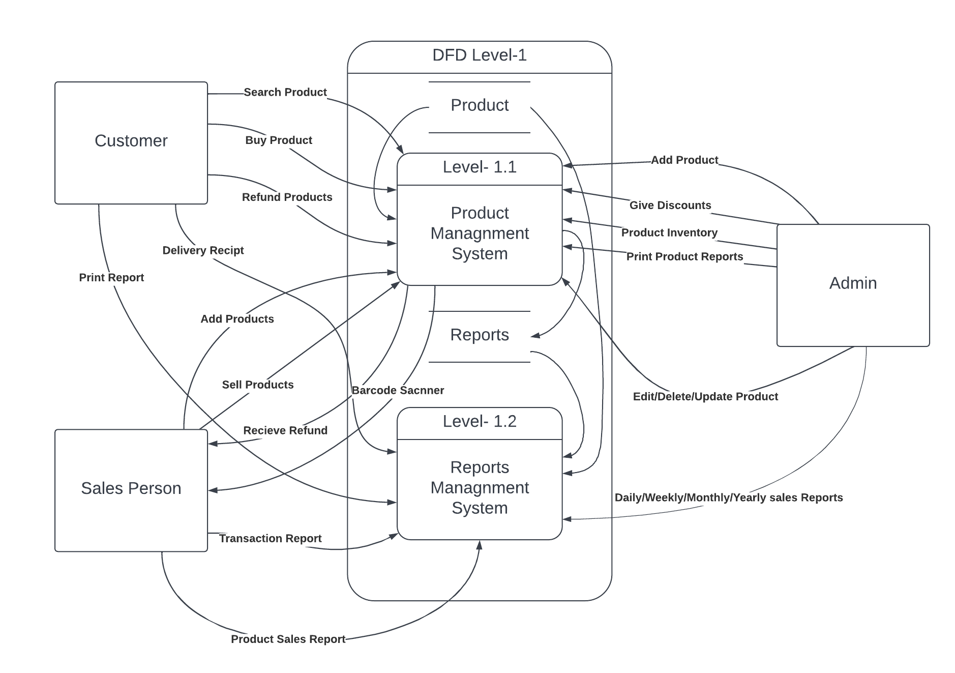

**4.3. ERD**

**4.4. Class Diagram**

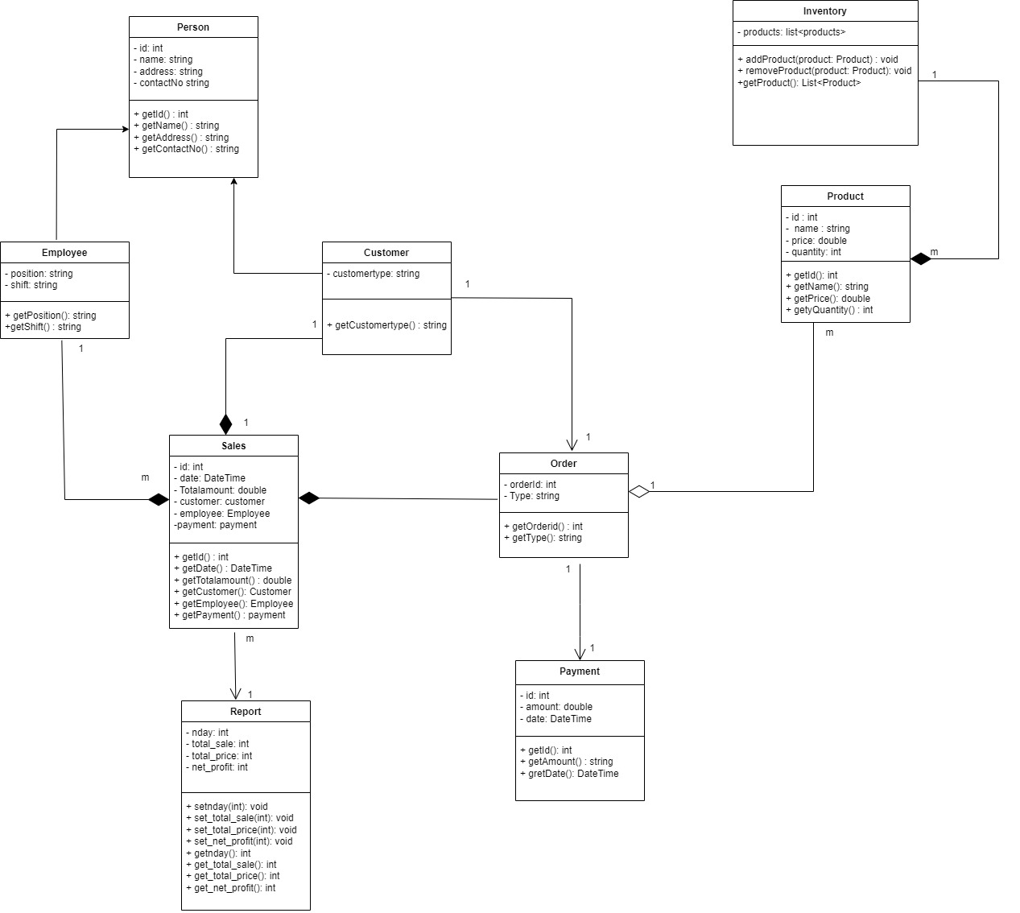

* 1. **Activity diagram**

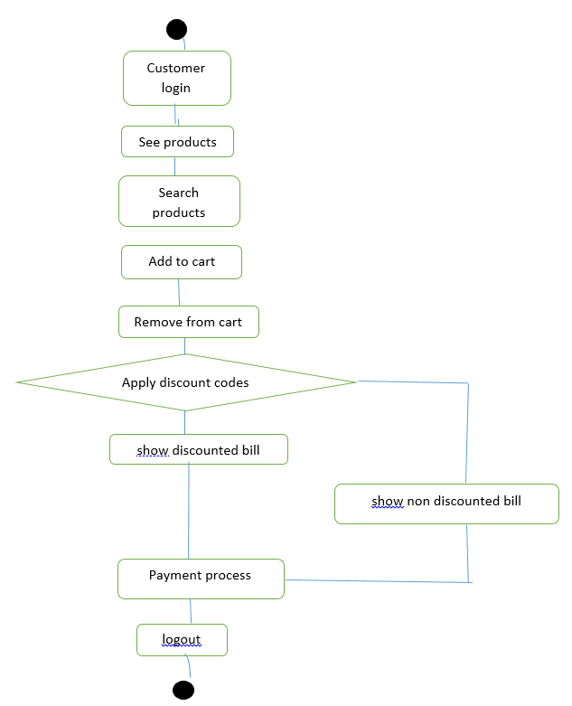

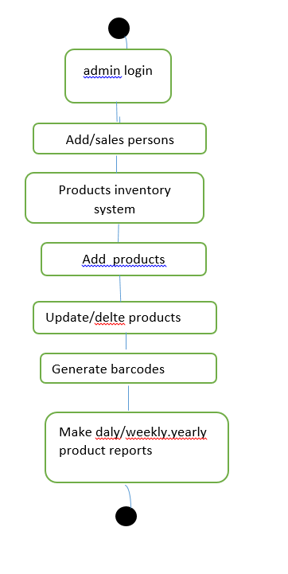

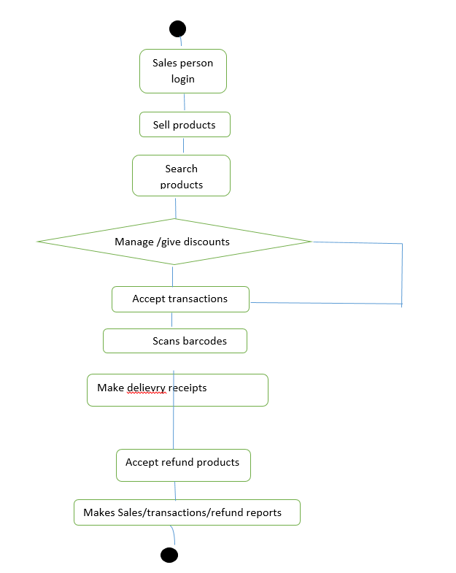

**5. External Interface Diagram**

**5.1. User Interface**

User increase will be very user friendly for the admin work and it will be easy and very smooth to work. No hurdle or difficulty to the admin while using this software.

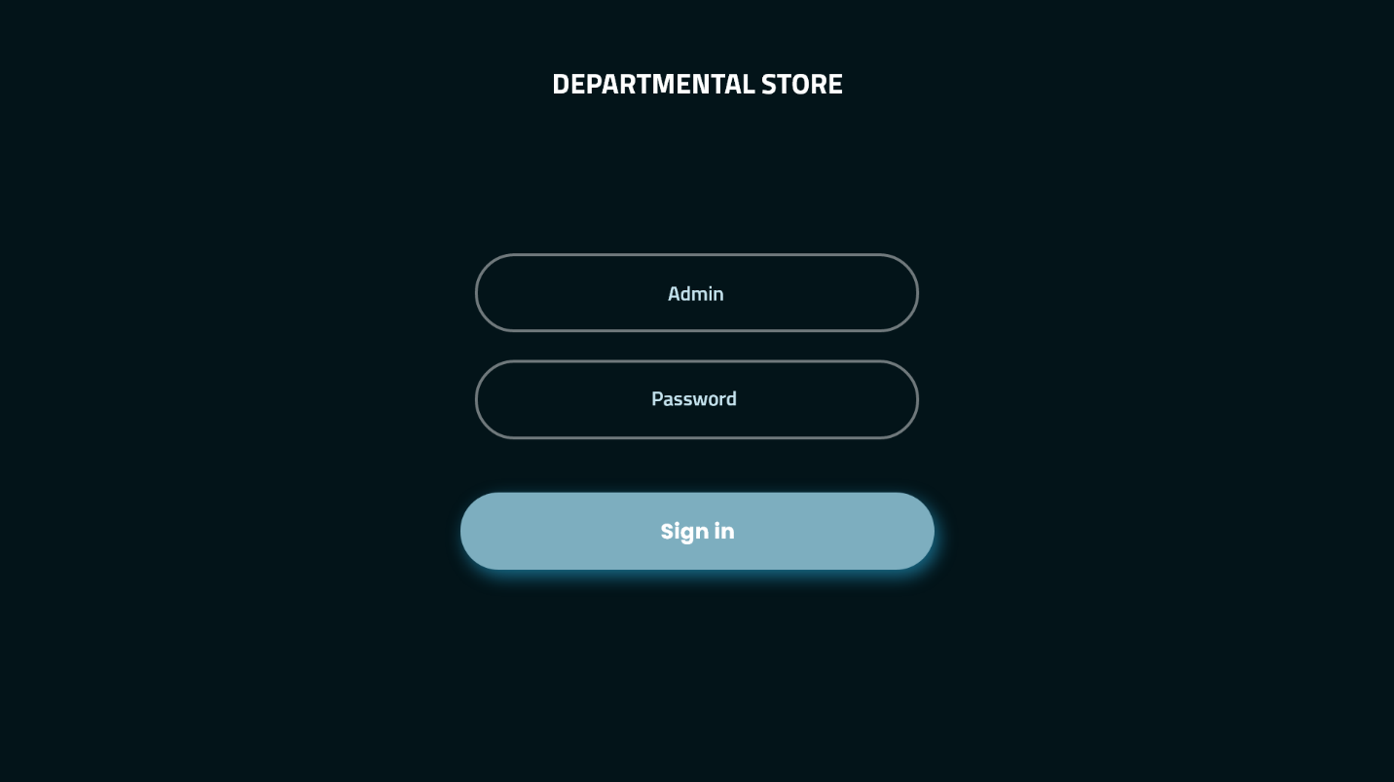

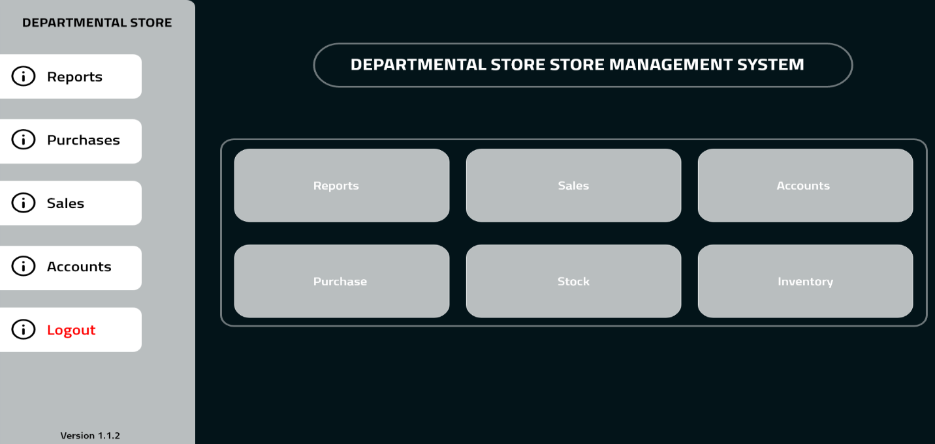

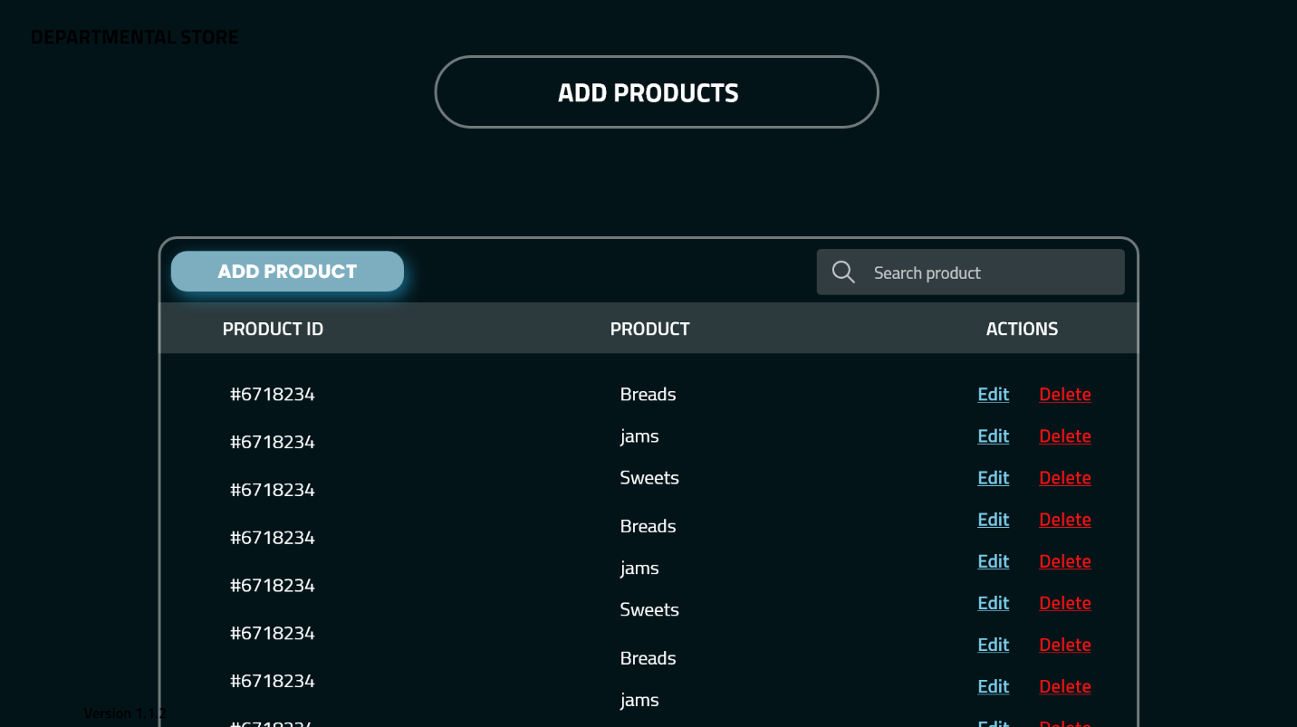

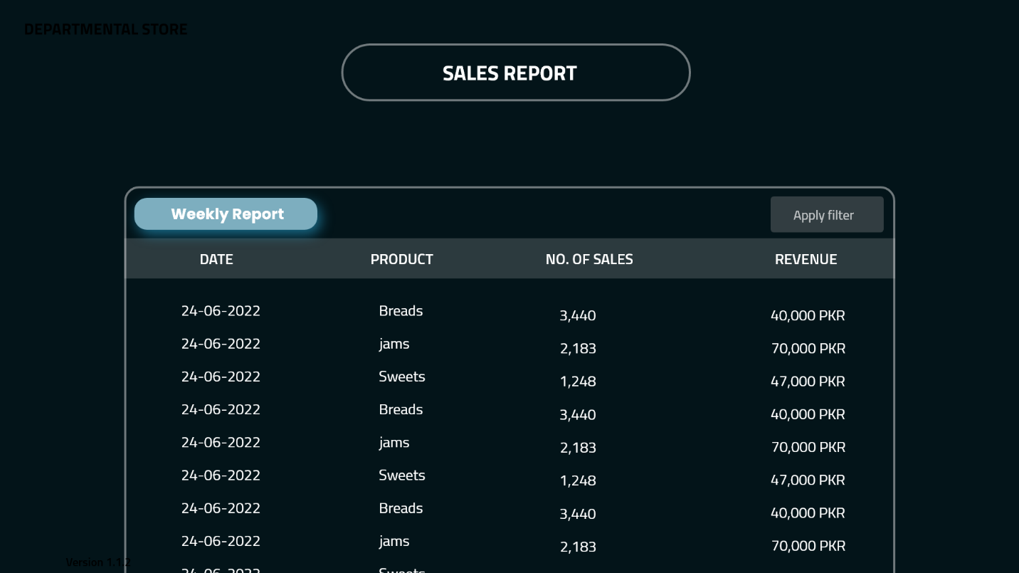

**6. Quality Attributes**

**6.1. Usability**

The system’s user interface should be easy to use so that if a new member is added he can easily learn to interact and use all the available features. The home screen tab should have only important features that will be less distracting and confusing, and the user interface should provide an overall positive user experience

**6.2. Performance**

The performance of the software is very important as it is going to be used all day so there should be no lag this can be achieved by a well optimized code so that the software can run-on low-end systems without any lag.

**6.3. Security**

The software system needs a robust security mechanism in place so that unauthorized users are not allowed access to Departmental store management system. All users of the system should at least be 18 years old must be uniquely identified. This could be done by using a username and associated password scheme that would authenticate and authorize the user access to the system and, if applicable, grant the user access to restricted or controlled Departmental store management system.

**6.4. Safety**

The software will have an inbuilt antivirus that will detect any virus that is already in the system or is trying to enter the system. Moreover, it will have a solution manager that will take care of errors that will reduce the need of maintenance.

**6.5. Maintainability**

The Software will be very easy to maintain because of the Following reasons:

* A standard naming convention will be set for classes
* All variable packages will be agreed upon.
* There will be a control system for all the source code and development related documents
* Well-defined coding standards will be used in all the source codes and documents

**6.6. Availability**

As **Swera store** is a known store there are a lot of customers all the time so the code for software will be well- optimized so there will be very less chance of error. The goal is that the software should be available for at least 99.5% of the time.